Setup a Hadoop Cluster Step by Step

In this exercise, you will learn how to set up a Hadoop cluster with 3 machines.

Environment

- Under Cloud OS
- 3 VM Ubuntu 20.04
- 1 master and 2 slaves

Step 1：Understand your nodes/instances
Suppose there are 3 students in your group, each student has created an instance on Tencent cloud. Let’s suppose the instances are named as: “johnzhang10”,” johnzhang11” and ”johnzhang12”.
Do not forget to associate floating IP for them (In Network Operation Tab).
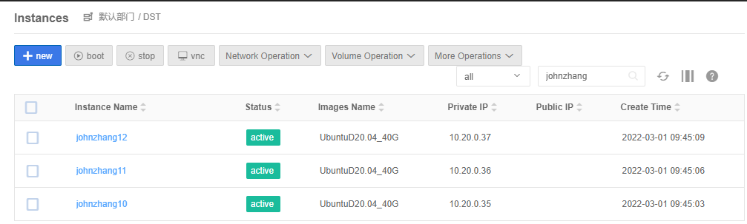

Check private and public IP and Host Name of all your nodes on the Cloud.

Caution!!!
If some of your nodes don’t have public IP, we suggest you use private IP to build your Hadoop cluster.
But you need to enable SecurityGroup for each machine in your group:
The steps are as follows:
Select the instance, click Network Operation menu, and select “Load SecurityGroup”
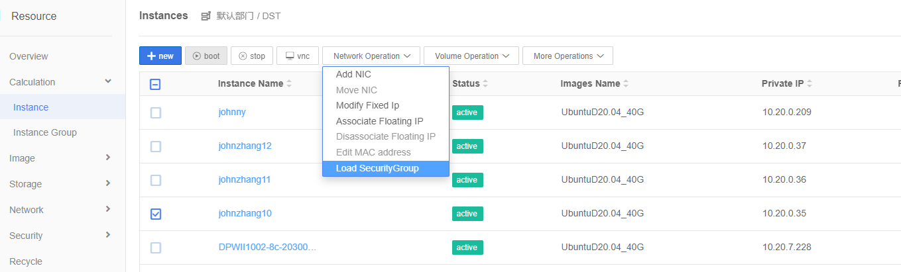
It will pop up a window as follows:
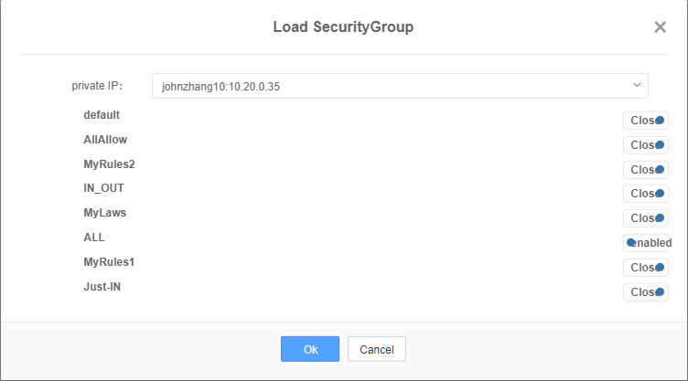
Select All and enable it, and click Ok button.
Repeat the above operation for each machine of your group.

Step 2: Modify Hosts
You should select one cloud machine for name node, the others are for data nodes. The image is “UbuntuD20.04”.
For example, I have created three cloud instances, names are johnzhang10 (private IP is 10.20.0.35 ), johnzhang11 (private IP is 10.20.0.36), and johnzhang12(private IP is 10.20.0.37).

Select the computer and click on vnc to open a terminal for that computer.

Edit domain name files.
Check your own IP and host name on the Cloud OS, please.
Open Terminal on the master host (johnzhang10, in my case, is selected as name node).
$ sudo vi /etc/hosts

enter your password and press ‘Enter’.
Then press the “Insert” button on your keyboard to edit the domain name file.
Modify the 3 IP addresses and corresponding names of your hosts into the file. Note that the names set in the host’s file should be the same as hostnames, otherwise unexpected errors will occur.
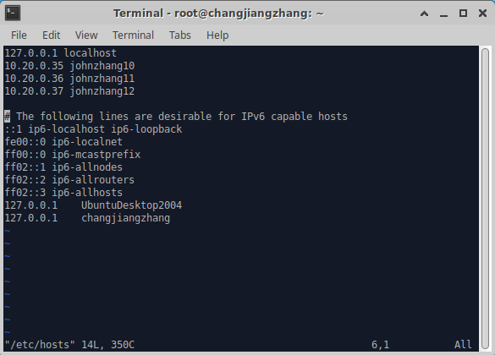
When finished, press “Esc” on your keyboard.
Input “:wq!” then press “Enter” to save and exit.
Remember this operation for vi editings. “w” means “write”, “q” means “quit”, “!” means “ obligatory”. If you just want to read and exit, just input “:q” then press “Enter”.
Do the same operations on the other two slave hosts (johnzhang11, johnzhang12).

On johnzhang11:
$ sudo vi /etc/hosts
172

On jonzhang12:
$ sudo vi /etc/hosts

Add the same contents to hosts file. Here in my case is as follows:
10.20.0.35 johnzhang10
10.20.0.36 johnzhang11
10.20.0.37 johnzhang12
You can also use public IP address here if you like

Your group has different IPs and names.

Step 3: Install JDK
On your master node (johnzhang10)
- Install JDK
If you have already done this before, skip 1.
$sudo apt install openjdk-8-jdk
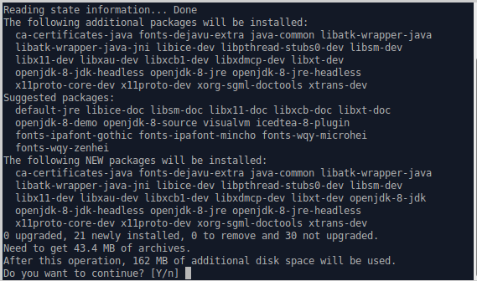
Input “Y” and press “Enter”.
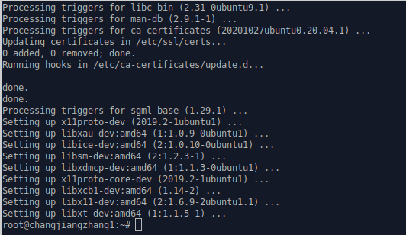

- Modify the system path file
$ sudo vi /etc/profile
Set the environment variables (operation mentioned above -- Insert, Esc, :wq!, Enter)
export JAVA_HOME=/usr/lib/jvm/java-8-openjdk-amd64/
export PATH=$PATH:$JAVA_HOME/bin
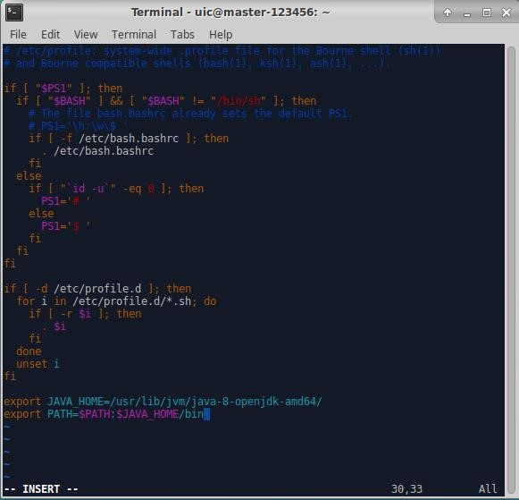

- Put the environment variable into effect immediately
$ source /etc/profile

- Verify
$ java -version
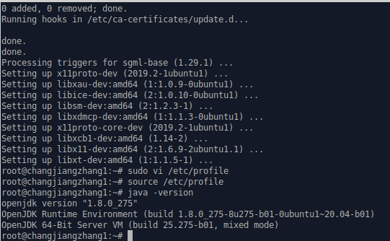
It is okay.
5. Install JDK on the two slave hosts.
(Repeat the above steps on the other machines)
If other machines have installed java before, you may only need to do 2-4 above.

Step 4: Set non-password login

# Why and how to set ssh non-password login:
http://www.linuxidc.com/Linux/2015-03/114709.htm

- Generate the public key of SSH.
$ ssh-keygen –t rsa –P ‘’ –f ~/.ssh/id_rsa
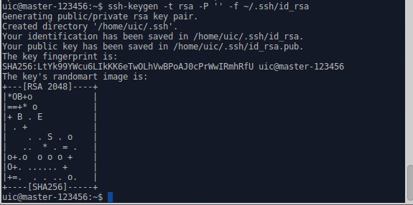
- Copy and send files

$ ssh-copy-id johnzhang11

$ ssh-copy-id johnzhang12

If your group has 4 students, you need perform ssh-copy-id to all machines, including master machine.
Do not forget connect the master self
$ ssh-copy-id localhost
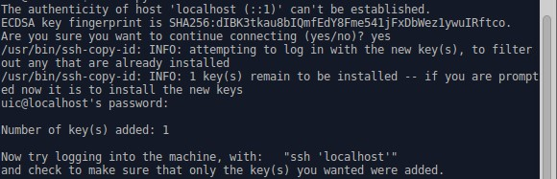

3 Then do the same operations on the other slave machines/hosts.

On one machine, such as johnzhang11:
Create a public key
$ ssh-keygen –t rsa –P ‘’ –f ~/.ssh/id_rsa
Copy the key to other machines
$ ssh-copy-id johnzhang10
$ ssh-copy-id johnzhang12

On johnzhang12:
Create a public key
$ ssh-keygen –t rsa –P ‘’ –f ~/.ssh/id_rsa
Copy the key to other machines
$ ssh-copy-id johnzhang10
$ ssh-copy-id johnzhang11

4. Test the ssh connection from master to all slaves.
On master: (johnzhang10)
Use ssh to connect johnzhang11
$ ssh johnzhang11
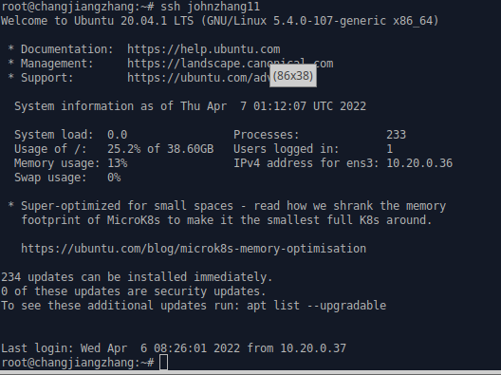

Use ssh to connect johnzhang12
$ ssh johnzhang12

If you have more machine, you need do the same operation above to check ssh connection.

Step 5：Hadoop Settings
On master machine
- Download
$ wget https://mirrors.tuna.tsinghua.edu.cn/apache/hadoop/common/hadoop-3.3.6/hadoop-3.3.6.tar.gz
(You can download newer version, which is also ok.)

- Unzip the file
We put it in the default directory (/root/hadoop-3.3.6). We choose this path just for convenience.
$ tar -zxvf hadoop-3.3.6.tar.gz
After unzip it, you will find Hadoop-3.3.6 in your home directory (shown as below)
Move hadoop-3.3.6 to /usr/local/hadoop
mv hadoop-3.3.6 /usr/local/hadoop
Step 6：Set Hadoop configuration files
- Set the environment variables
$ sudo vi ~/.bashrc
export HADOOP_HOME=/usr/local/hadoop
export JAVA_HOME=/usr/lib/jvm/java-8-openjdk-amd64/
export PATH=$PATH:$JAVA_HOME/bin:$HADOOP_HOME/bin:$HADOOP_HOME/sbin
export HADOOP_CLASSPATH=$JAVA_HOME/lib/tools.jar
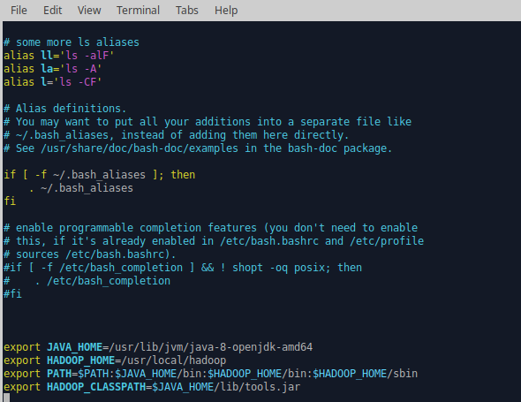
Type the command to execute the script:
$ source ~/.bashrc

2. Configure hadoop-env.sh and yarn-env.sh
$ cd /usr/local/hadoop/etc/hadoop
$ sudo vi hadoop-env.sh
export JAVA_HOME=/usr/lib/jvm/java-8-openjdk-amd64

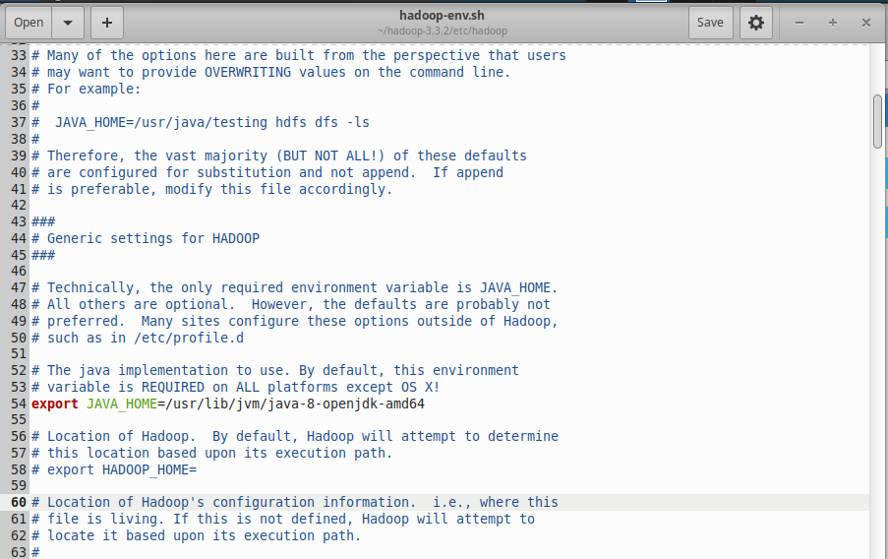
Save the changes
Press <esc> to exit insert status
type :wq!

$ sudo vi yarn-env.sh
export JAVA_HOME=/usr/lib/jvm/java-8-openjdk-amd64
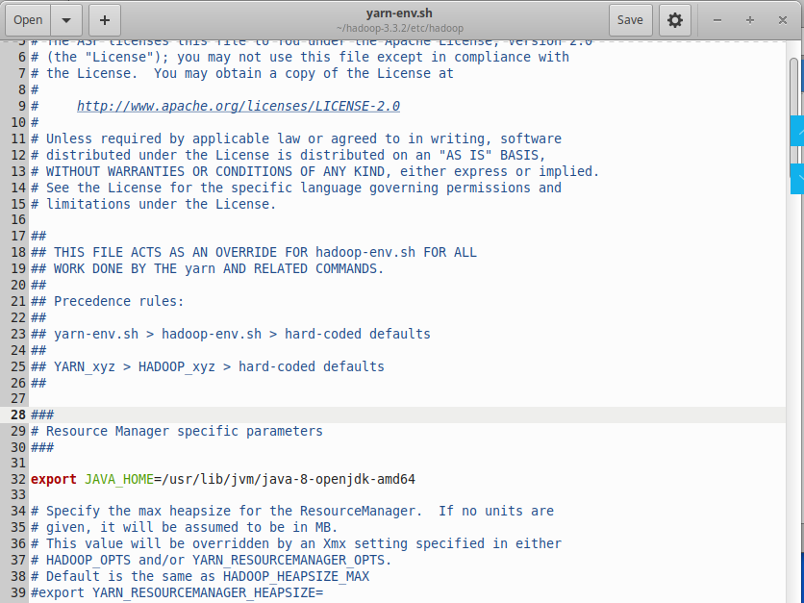

Save the changes
Press <esc> to exit insert status
type :wq!

Note: we need create the following two directories for the following configuration:
/usr/local/hadoop/tmp
/usr/local/hadoop/hdfs
(you may already have /usr/local/hadoop/hdfs, then you need delete all files in this directory)

$ cd /usr/local/hadoop
$ mkdir tmp
$ mkdir hdfs
Or use GUI to create the above two directories.

3. configure core-site.xml
$ cd /usr/local/hadoop/etc/hadoop
$ sudo vi core-site.xml
<configuration>
<property>
<name>fs.defaultFS</name>
<value>hdfs://10.20.0.35:9000</value>
</property>
<property>
<name>hadoop.tmp.dir</name>
<value>/usr/local/hadoop/tmp</value>
</property>
</configuration>

4. configure mapred-site.xml
$ sudo vi mapred-site.xml
<configuration>
<property>
<name>mapreduce.framework.name</name>
<value>yarn</value>
</property>
<property>
<name>mapred.job.tracker</name>
<value>10.20.0.35:9001</value>
</property>
<property>
<name>mapred.job.dir</name>
<value>/usr/local/hadoop/var</value>
</property>
<property>
<name>yarn.app.mapreduce.am.env</name>
<value>HADOOP_MAPRED_HOME=/usr/local/hadoop</value>
</property>
<property>
<name>mapreduce.map.env</name>
<value>HADOOP_MAPRED_HOME=/usr/local/hadoop</value>
</property>
<property>
<name>mapreduce.reduce.env</name>
<value>HADOOP_MAPRED_HOME=/usr/local/hadoop</value>
</property>
</configuration>

5. configure hdfs-site.xml
$ sudo vi hdfs-site.xml
<configuration>
<property>
<name>dfs.replication</name>
<value>2</value>
</property>
<property>
<name>dfs.namenode.name.dir</name>
<value>file:/usr/local/hadoop/hdfs/namenode</value>
</property>
<property>
<name>dfs.datanode.data.dir</name>
<value>file:/usr/local/hadoop/hdfs/datanode</value>
</property>
</configuration>

6. configure yarn-site.xml
$ sudo vi yarn-site.xml
<configuration>
<property>
<name>yarn.resourcemanager.hostname</name>
<value>10.20.0.35</value>
</property>
<property>
<name>yarn.nodemanager.aux-services</name>
<value>mapreduce_shuffle</value>
</property>
<property>
<name>yarn.nodemanager.vmem-check-enabled</name>
<value>false</value>
</property>
</configuration>

- Set slave nodes
$ cd /usr/local/hadoop/etc/hadoop
Revise the file workers, delete the line of localhost, add all data nodes machine names in it. For example:

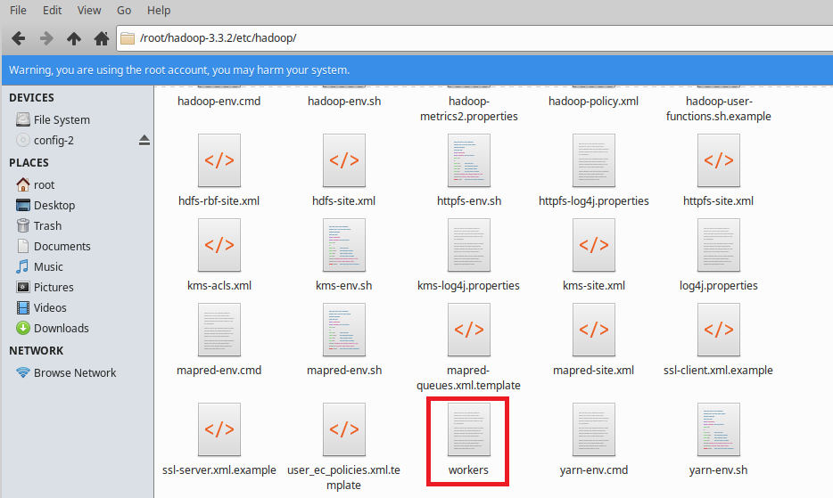

$sudo vi workers
Johnzhang11
Johnzhang12

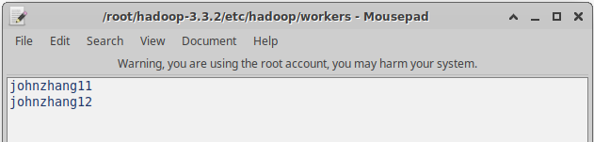

- Copy files to other data/slave nodes
Before copy to other machines, make sure /usr/local/Hadoop/hdfs is empty!
No file in this directory.
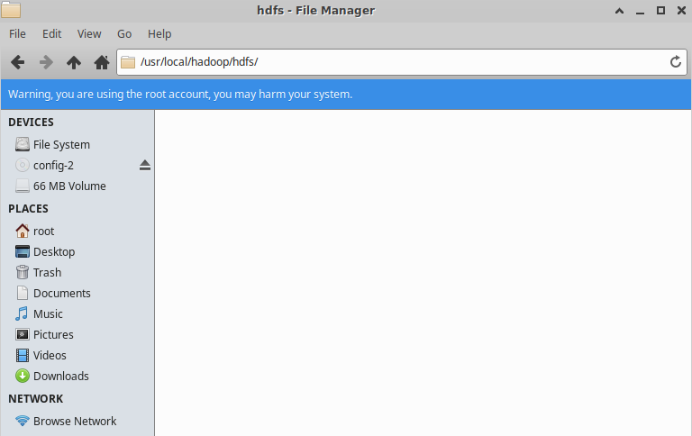

$ scp -r /usr/local/hadoop/ root@johnzhang11:/usr/local/hadoop
$ scp -r /usr/local/hadoop/ root@johnzhang12:/usr/local/hadoop

Here, suppose johnzhang11 and johnzhang12 is your other two machine name (data node)
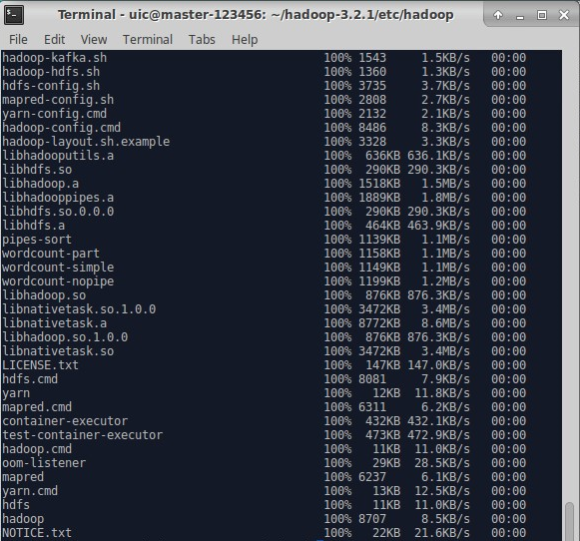

Step 7： Test Hadoop
- Format distributed file system
On your name node machine, type the following command
$ hdfs namenode –format

$ cd /usr/local/hadoop/sbin
Modify start-dfs.sh, stop-dfs.sh,
add the following lines in these two files above.
HDFS_DATANODE_USER=root
HDFS_DATANODE_SECURE_USER=hdfs
HDFS_NAMENODE_USER=root
HDFS_SECONDARYNAMENODE_USER=root

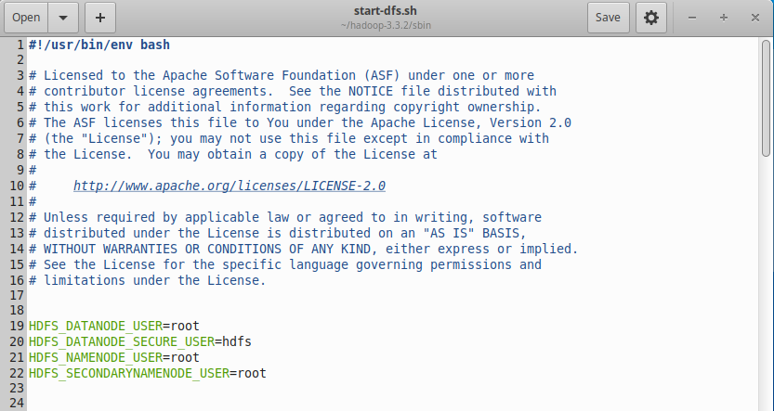
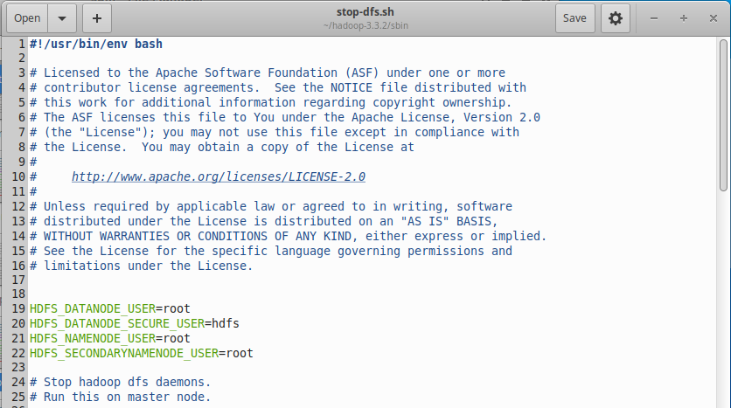

Modify start-yarn.sh and stop-yarn.sh, add the following lines in these two files.
YARN_RESOURCEMANAGER_USER=root
HDFS_DATANODE_SECURE_USER=yarn
YARN_NODEMANAGER_USER=root
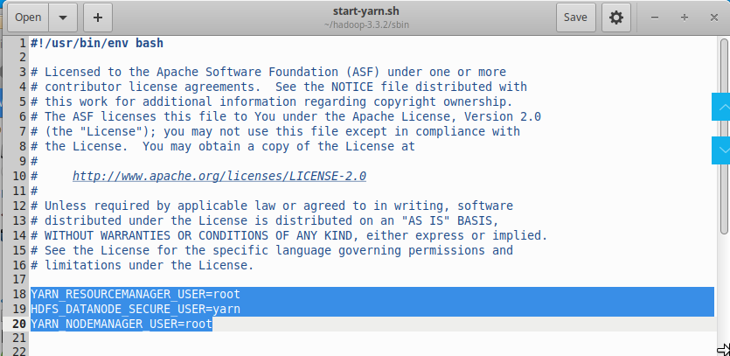
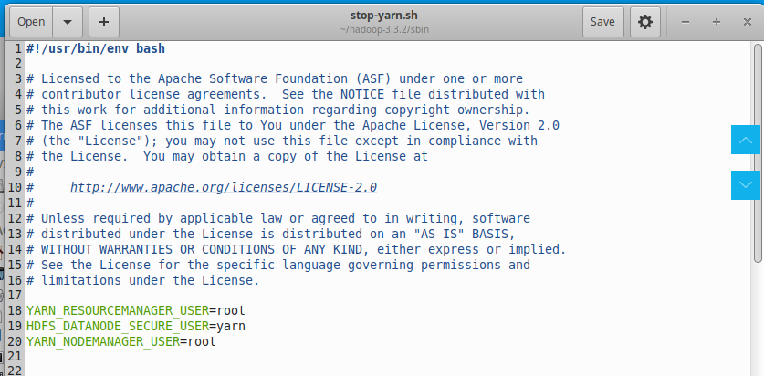

- Start Hadoop systems
$ start-dfs.sh

$start-yarn.sh

- Verify if it is successful
On master host, there should be:
NameNode, SecondaryNameNode, Jps and ResourceManager.
$ jps
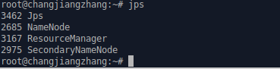

On any slave hosts, there should be: Jps, DataNode and NodeManager.
$ jps
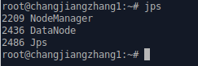
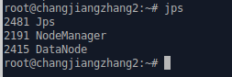
It is successful.
- Stop
$ stop-dfs.sh
$ stop-yarn.sh

Note:
If perform “hdfs namenode –format” more than one time, you may encounter the problem that DataNode cannot start.
Try the following operation:
On the master host:
$ stop-dfs.sh
$ stop-yarn.sh

On all machines:
Delete all files/subdirectories under /usr/local/hadoop/hdfs
$ rm –rf /usr/local/hadoop/hdfs/*
Now, format namenode again.

On the master host:
$ hdfs namenode –format

Start Hadoop again
$ start-dfs.sh
$ start-yarn.sh

Then you will find that the DataNodes start normally.

5. test hdfs commands (notice if you created the path)

Create the directories under HDFS
$ hdfs dfs –mkdir /input

Upload some files to a specified directory with the same file name.
(suppose you have the file01.txt in your current directory)
$ hdfs dfs -put file0* /input
View the contents in the directory on HDFS.
$ hdfs dfs –cat /input/file01.txt

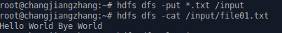

List the files under HDFS.
$ hdfs dfs -ls /input

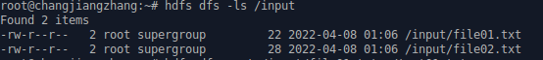

Get the file file01.txt from HDFS to your home directory and rename it as test01.txt
$ hdfs dfs -get /input/file01.txt ~/test01.txt
$ ls
$ cat test01.txt

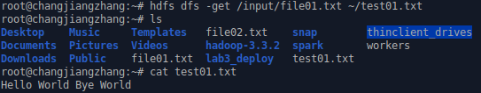

Delete the specified file file01.txt from HDFS.
$ hdfs dfs -rm /input/file01.txt
$ hdfs dfs -ls /input

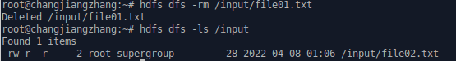

View basic statistics for HDFS.
$ hdfs dfsadmin –report

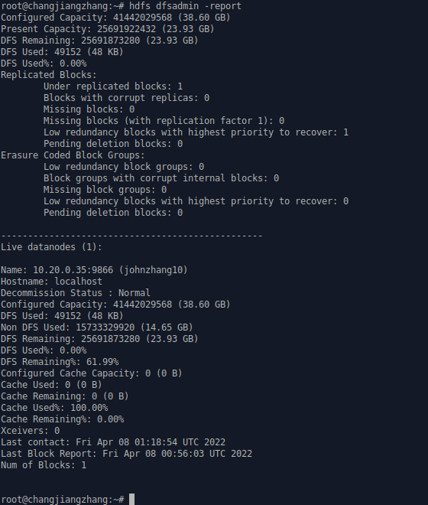

6. Web interface
Once the Hadoop cluster is up and running check the web-ui of the components as described below:
To check the namenode information: http://johnzhang10:9870
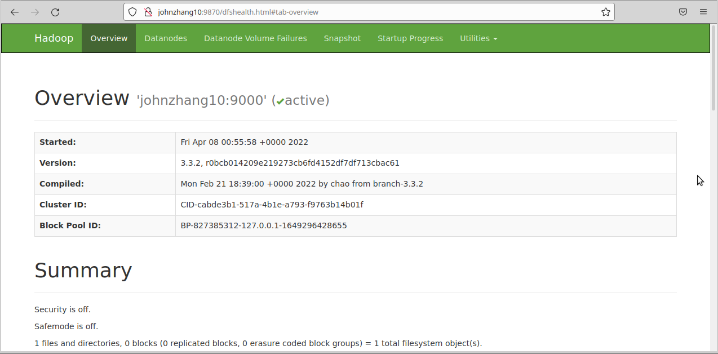
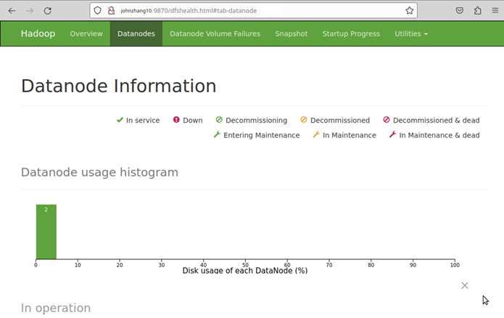
To check the resource manager information: http://johnzhang10:8088

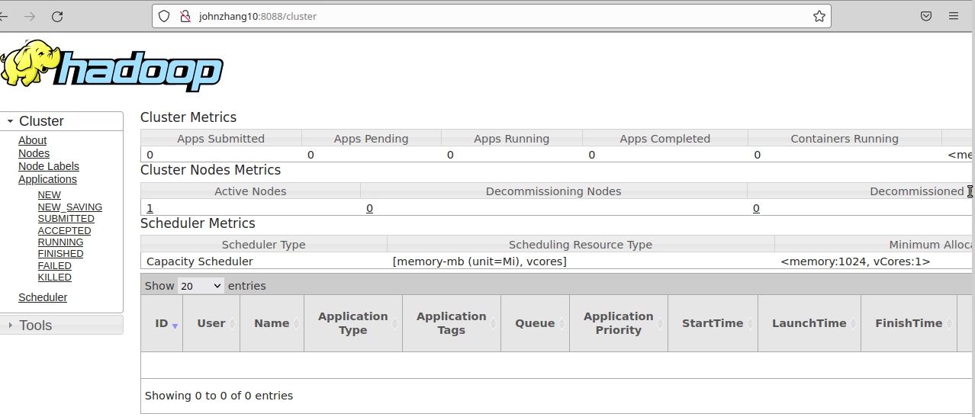

7. Redo the lab4 part two on this Hadoop cluster.
Create /invIndex directory in hdfs
$ hdfs dfs –mkdir /invIndex
Upload books you used in lab4 to this directory
Suppose your books is saved in your home directory /book
$ hdfs-dfs –put ~/book /invIndex
Run the program InvIndex.jar :
$ hadoop jar InvIndex.jar InvertedIndex /invIndex /invIndex/output

Check the result
$ hdfs dfs –cat /invIndex/output/part-r-00000

